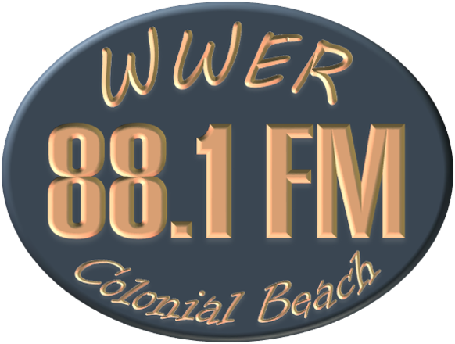
Colonial Beach Community Radio
We ARE Colonial Beach
106 Hawthorne Street
Colonial Beach VA 22443
http://wwer.org
info@wwer.org

WWER 88.1 airs Public Service Announcements (PSAs) for non-profit organizations for special events and activities. We air these announcements as time, space and manpower permit. Information about the activity must be submitted via email to info@WWER.org at least 2 weeks prior to the event.
Name of Activity:
Date(s) of Activity:
Time(s) of Activity:
Location of Activity:
Street Address:
City, State, Zip Code:
Phone Number for More Information:
Name of Organization requesting announcement:
Mission of Organization requesting announcement:
Other Information: Please include all information about your event, activity, or special service—too much information is better than not enough—text box expands as your type:
Name of person submitting PSA:
Email of person submitting PSA:
Phone of person submitting PSA:

